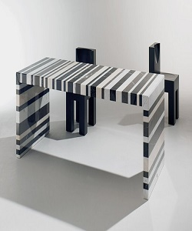

Coffee Table

$29.41

Availability: In stock

**Description:**

This stiped table brings a bit of contemporary appeal to any ensemble in your home. A clear striped glossy top provides a place for any items you want to show off, while boxy sled-style base below sports a sleek metallic finish for an on-tred look. This narrow design is perfect look for living room. Assembly is required.